USING MACHINE LEARNING ALGORITHMS TO PREDICT SALARIES IN THE NATIONAL HOCKEY LEAGUE (NHL)

A Project

Presented

To the Faculty of

California State University, Dominguez Hills

In Partial Fulfillment

of the Requirements for the Degree

Master of Science

in

Computer Science

By

Matthew Gilbody

Spring 2023

USING MACHINE LEARNING ALGORITHMS TO PREDICT SALARIES IN THE NATIONAL HOCKEY LEAGUE (NHL)

AUTHOR: MATTHEW GILBODY

APPROVED:

Jianchao “Jack” Han, PhD.

Project Committee Chair

Bin Tang, PhD.

Committee Member

Alexander Chen, PhD.

Committee Member

ACKNOWLEDGEMENTS

I would like to thank all my committee members for their guidance and belief in me for the duration of my project. I would also like to thank the university for assisting us students and faculty through the difficult times of covid and for the years I spent here throughout my bachelors and my masters.

I would also like to thank the Toro Learning and Testing Center who was my employer throughout the duration of my masters program. They provided me with unwavering support and gave me the opportunity to connect with students and faculty, which is something I regret not doing while getting my bachelors.

Finally, I would like to thank my family and friends who always showed tremendous support. They pushed me, believed in me, and encouraged me to push through when feelings of self-doubt came into the picture. All of this could not have been achieved without their support and the aforementioned people.

TABLE OF CONTENTS

ACKNOWLEDGEMENTS iii

TABLE OF CONTENTS iv

LIST OF FIGURES v

ABSTRACT vi

1. INTRODUCTION 7
2. THE PROBLEM AND BACKGROUND 7
3. THE DATA 10
4. ALGORITHMS AND METHODS 14
5. ALGORITHM RESULTS AND COMPARISON 21
6. CONCLUSION 27

WORKS CITED 29

APPENDIX A: GLOSSARY OF TERMS 31

LIST OF FIGURES

1. Project Flow Chart 9
2. NHL Centers Data Summary 11
3. NHL Wingers Data Summary 12
4. NHL Defense Data Summary 13
5. Random Forest Architecture 14
6. Sample Tree from Algorithm 15
7. RF Feature Selection 16
8. Correlation Map for Centers 18
9. Scatterplot Stats and Cap Hit 19
10. Random Forest Results 22
11. RF Defense Predictions 23
12. RF Wingers Predictions 23
13. RF Centers Predictions 23
14. MLR Results 24
15. MLR Defense Predictions 24
16. MLR Wingers Predictions 25
17. MLR Centers Predictions 25
18. Lasso Results 25
19. Lasso Defense Predictions 26
20. Lasso Wingers Predictions 26
21. Lasso Centers Predictions 27

ABSTRACT

The world of analytics has grown over the last few years. Most companies are making decisions based off of data driven insights and the major sports leagues are no different. Ever since the release of *Moneyball*, the idea of using statistics to find value in players has become increasingly popular. Teams across all the major sports leagues are investing heavily into analytics and using the insights that they gain to make decisions, such as, strategy, marketing, salary, trades, etc. This paper aims to take data from the current NHL season and use various machine learning algorithms, such as, random forest, lasso regression, and multiple linear regression in order to predict player salary based on player statistics. We will look at how each algorithm works, how well they performed, and what factors go into making their predictions.

CHAPTER 1

INTRODUCTION

Performance is a big factor when it comes to financial compensation. No matter what the profession, performance is often analyzed and can lead to increased compensation or being terminated, and nowhere is this truer than in the world of sports. Players are signed to term contracts and the value of those contracts is highly dependent on what kind of value the player brings to the franchise. Player salary has become an intense topic. Players across the various major sports leagues feel that their value has increased and have turned to tactics such as requesting trades, holding out, and refusing to engage in team activities in order to increase pressure on the team to give them the financial compensation that they feel they deserve. On the other side of the coin, teams often must navigate hard salary caps, making it tricky to sign top players, while still fielding competitive teams. This paper is going to focus on the National Hockey League (NHL). The goal of this paper is to find out what goes into determining a player’s salary. In the upcoming sections, I will discuss the data that is used and how the data has been transformed and broken down. I will also discuss the various algorithms that were used to obtain the predictions, the results, and the conclusions that I drew from the project.

CHAPTER 2

THE PROBLEM AND BACKGROUND

1. Background

The NHL is one of four major sports leagues in the United States and pulls in billions of dollars each year. While still not as popular as football, baseball, or basketball, the league has boosted its popularity and according to Forbes, “Hockey team owners are scoring big, with the average NHL team value now $1.03 billion, topping $1 billion for the first time and 19% more than a year ago” (“NHL Team Values 2022”, 2022). Hockey has always been a violent sport, but with the influx of highly skilled players and lower levels of fighting, hockey has seen an increase in popularity. According to a Frontiers article by Fortney et. Al, “NHL fighting rates have diminished during the past two decades, while fan attendance has increased. A significant negative correlation exists between fan attendance and fights per game, casting doubt on fighting’s entertainment value” (Fortney et. Al). With this influx of talent comes an influx in player salaries. According to a hockeyskillstraining.com article, “In 1990, Wayne Gretzky was the highest paid player in the NHL at $3 million per season” (“NHL Salaries Over the Years”) and according to the data set used in this project, the average salary is around $3 million. Wayne Gretzky is considered to be the greatest player to ever step on the ice, and even though $3 million was considered great money in 1990, when it is adjusted for inflation to the modern day, it’s only around $7 million. Some players are currently making $12.5 million, and that number is only going to increase as time goes on.

The biggest problem that teams have to face is constructing a competitive roster while staying within the constraints of the salary cap. This can be hard to reconcile as investing a lot of money into a few players can have lasting impacts on the long term success of a franchise. Allocating large sums of money to a few players limits the flexibility a team has, meaning they’ll have to sign more average performing players. As previously mentioned, I am going to explore what goes into determining a player’s salary.

1. Description and Objectives

The goal of this paper is to determine which factors are most important in determining a player’s salary, how accurate the models are at predicting player salary, and if there are other factors outside of player performance that go into determining a player’s value. Player performance data will be run through 3 machine learning algorithms: random forest, multiple linear regression, and lasso regression, and the results of these algorithms will be compared. Some of the objectives include:

* To see which player stats are most useful in predicting player salary.
* To see which algorithm performs the best and is the most accurate in predicting player salary.
* To locate the most important performance stats and drop the least important to see if our model improves.
* To separate players based upon the positions they play to produce more accurate results.
* To explore how the algorithms pick their most important features.

1. Design and Implementation

Figure 1

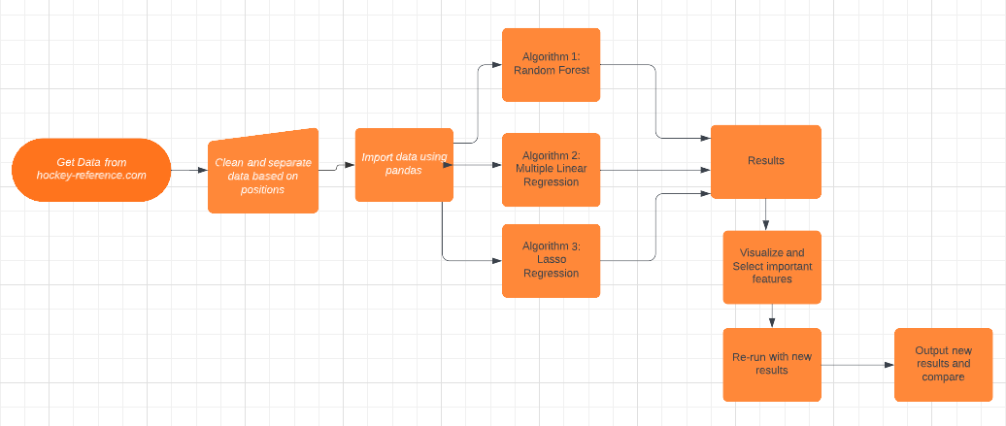

Figure 1 represents the process of this project. Our first step is to gather and load the dataset into excel. From there, I separated the players based upon their position to obtain more accurate results in the predictions. The next section goes into further detail on how and why the data was separated and cleaned. The next steps were to import the data and run them through the 3 machine learning algorithms. From there we produced preliminary results and showed which features were most prominent in determining player salary. From there, I dropped the features that had a negative correlation to the dependent variable (salary) and re-ran the data through the algorithms to produce new results in the hopes that our predictions could be more accurate and confident. Each data set was run through each algorithm. There were a total of 3 sets of data used (centers, wingers, and defensemen). Pycharm was used as the IDE for this project and all the data was cleaned using excel.

CHAPTER 3

THE DATA

The data for this project was collected from hockey-reference.com and includes players’ basic statistics, advanced statistics and their respective cap hit from the current 2022-2023 season. I chose cap hit versus their actual salary, because cap hit is the annual average value (AAV) of their contract. Using their salary isn’t as efficient, because the way some contracts are set up, a player’s actual salary can be different each year depending on the structure of the contract. I broke up the data into 3 separate parts: defense, centers and wingers. I did this because each of these positions contributes differently and I wanted to see how differently each algorithm would determine the variables that are most important for that position. Each of these positions could be broken down even more. I could separate based upon the lines they play on, how much power play time the players get, handedness they are, where they were drafted, etc. but I chose to not break it down that far. Separating them into their broad positional categories is sufficient for this study. Players who have played less than 10 games were excluded from the project as that is not enough data to draw any meaningful conclusions. Goalies were not included in this project as well. In the sections that follow, I will mainly show visualizations from the NHL Centers data. This is to reduce redundancy and to make this paper more concise. I will share the results for all positions in the results section.

The data was cleaned using excel. I was able to connect to the web and load the data into an excel worksheet. From there, I was able to merge queries, rename the columns, delete certain columns, and separate the various positions. Once I was satisfied with the data, I converted the file from an excel workbook to a CSV (comma separated file). Another method of doing this is by using the pandas library. I mainly used pandas to read in the CSV files, get the basic data from the file, show a correlation matrix, and format the results of the predictions. Pandas is a very powerful data manipulation tool, but I chose to work in excel to clean the data. This allowed me to focus on implementing the algorithms on the data.

Figure 2

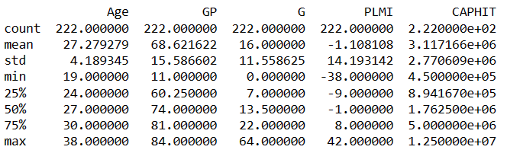

Figure 1 represents a small summary of the “NHL Centers” data table. Centers have the most responsibility on the ice as they are tasked with face offs, providing offense, while also helping on defense. Figure 1 gives a breakdown of 5 categories from the data on centers. There are 222 centers that were a part of this study. I would expect faceoff win percentage, their scoring ability, their plus/minus, and some defensive stats to play prominent roles in determining their value. We can see that the highest paid center is $12.5 million, while the lowest paid center is $450,000 and the average sits at just above $3 million.

Figure 3

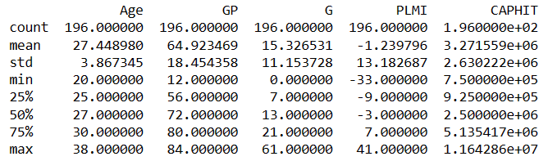

Figure 2 represents a small summary of the “NHL Wingers” data table. Wingers play alongside centers and are mainly responsible for providing offense. They do have some defensive responsibility, but wingers are more expected to provide scoring. We have slightly less players in this data pool than we do centers, but we see that there are similar averages across the board. For wingers, I would expect goals scored, assists, points, plus/minus, and other offensive minded stats will be more prominent in determining their value.

Figure 4

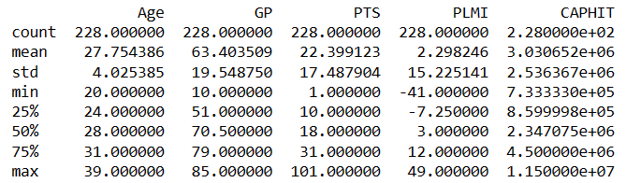

Figure 3 represents a small summary of the “NHL Defense'' data table. Defensemen focus on keeping the puck out of their own net more than they do about putting the puck in the net of their opponent. They are the last line of defense before it gets to the goalie. Higher paid defensemen bring a higher grade of offense than most defensemen in the league, but it isn’t their primary responsibility. We see similar averages in age and cap hit for all positions, but we won’t see the same when it comes to scoring. For defensemen, I would expect to see plus/minus, total time on ice, age, and other defensive stats to be more prominent in determining their value.

CHAPTER 4

ALGORITHMS AND METHODS

1. Random Forest

Figure 5

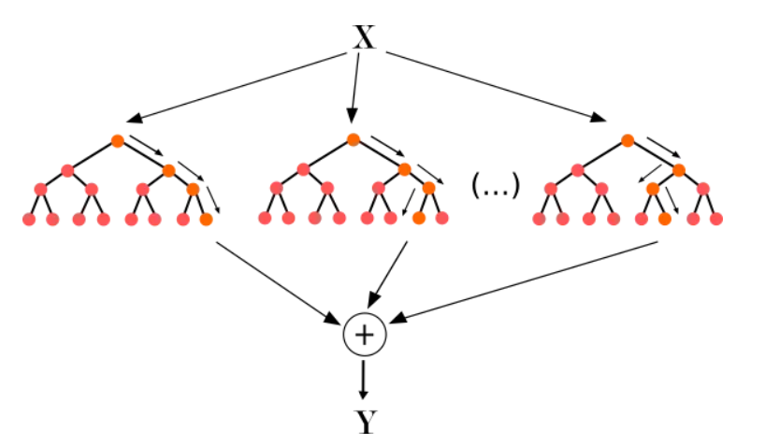

The first method that I used was the random forest algorithm. Random Forest is as exactly as the name implies. It’s a collection of decision trees where independent variables are chosen at random and split until a final node is reached. Once each tree has made its prediction, it will combine the results from all the trees and output a final prediction. Figure 5 is a pictorial representation of the Random Forest architecture where “x” represents the starting node. Each tree then makes a binary split and produces a result, “k”. Once each tree has produced its result, all the results are combined and the average produces our final result. It can be represented in an equation as follows:

k(final) = (k1 + k2 + k3…+kn)/n

Random Forest is considered to be one of the most effective algorithms when it comes to classification and regression problems. The reason being, features are randomly selected, regardless of which features are deemed the most important, making each tree independent of one another. Li writes, “RF will take random selection for features (predictors in the research, like age, goal......) rather than always using all features to train the decision trees” (Li, pg. 10). In this case, the final prediction is a result of the average taken from all the individual predictions from each tree. If we were doing classification, then the final prediction would be the result of a majority vote. As previously mentioned, there are 3 different categories of NHL players. Each category was run through the algorithm.

Figure 6

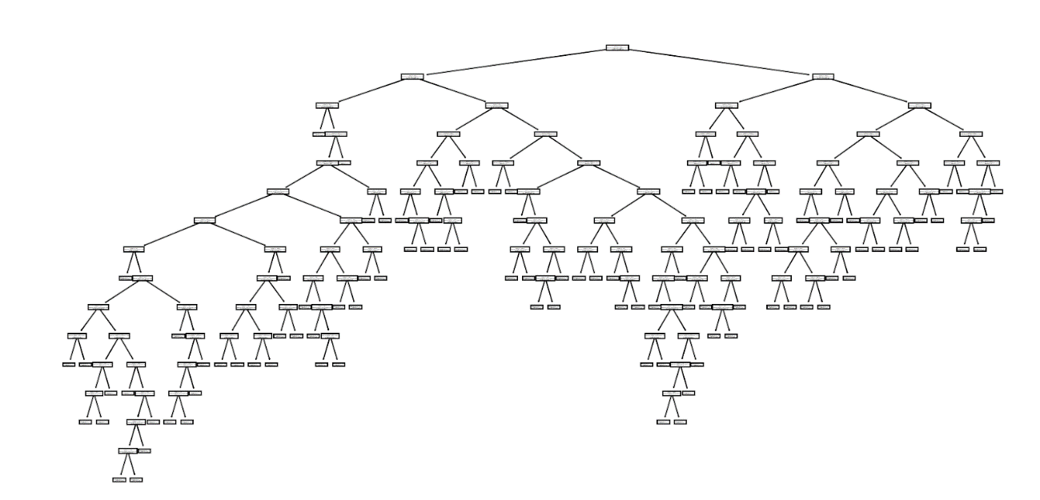

Figure 4 is an example of a decision tree from our Random Forest. Unfortunately, the image was too large and I couldn’t see what each node was split at, but it offers a glimpse into the structure of the tree and what happens during the process. Each tree begins with a randomly chosen condition and bakes a binary split at each node until an ending condition is reached. Once each tree outputs its prediction, they can all be averaged out to form the final prediction. For this project, I created 100 trees for all centers, wingers, and defensemen. I used 80% of the data as the training data and the remainder was used as the test data. This was done for centers, wingers, and defensemen.

Figure 7

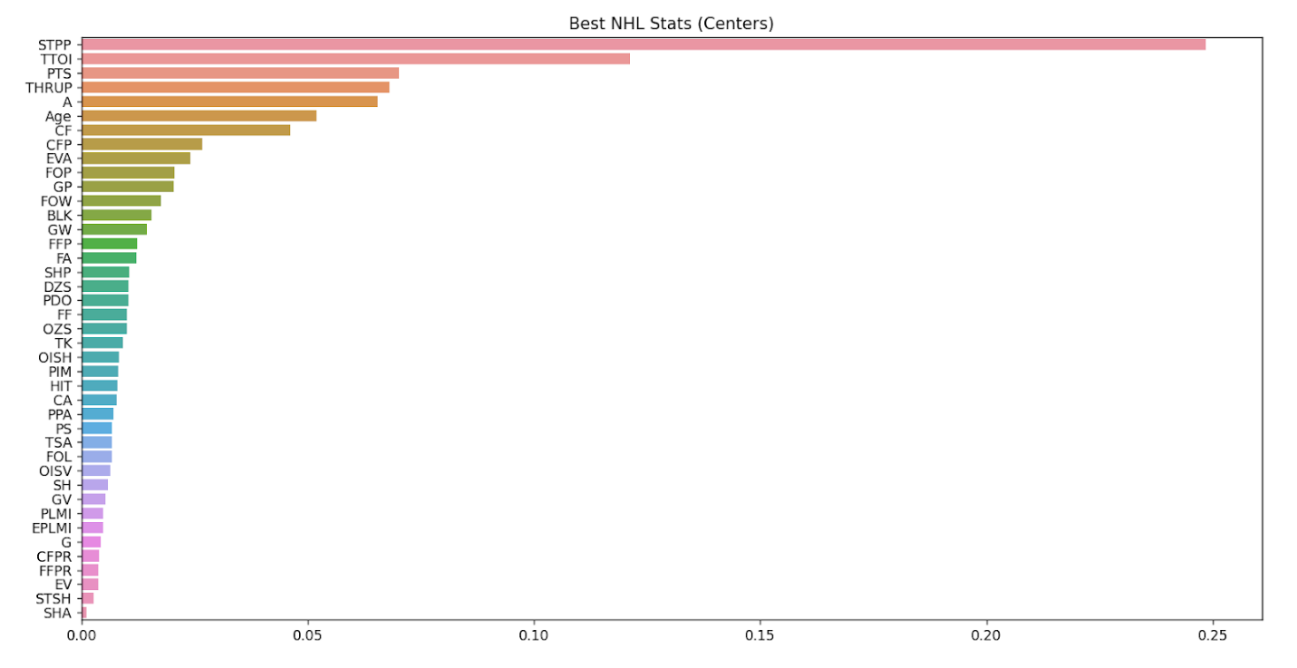

The above graph depicts the most important features ranked from most important to least important for centers in the NHL. The Random Forest model will calculate the features that bring less impurity to the model. The scores above are an indication of how well the feature decreases the impurity of the tree when a node is split at that feature. This can be calculated by the gini importance. According to an article from Medium, “Gini Importance or Mean Decrease in Impurity (MDI) calculates each feature importance as the sum over the number of splits (across all trees) that include the feature, proportionally to the number of samples it splits” (Lee).

There are similar figures for wingers and defensemen. The top 3 features that the model selected for centers are power play goals (STPP), total time on ice (TTOI), and points (P), while the bottom 3 features are even strength (EV), short-handed goals (STSH), and short-handed assists (SHA). While face-off win (FOW) looked to be among the better features, I would have expected it to rank in the top 3. Centers have a large responsibility with face-offs. Face-offs really impact the game in many ways, so a player with a high face-off win percentage proves himself to be highly effective. The model was run once before feature selection was performed and then once after. Once the features were selected and ranked, the bottom two features were dropped to see if that improved our initial prediction.

1. Multiple Linear Regression

Multiple Linear Regression (MLR) is a machine learning algorithm that takes more than one independent variable to make a prediction on the dependent variable. Multiple linear regression uses all the features in the dataset to output its predictions, unless features are manually removed. In this case, our dependent variable is the player’s cap hit, since this is what we are trying to predict, and the independent variables are the quantifiable stats, such as the amount of goals they scored. In their paper, Tonack used a MLR model for evaluating centers. Tonack states, “The multiple linear regression model solves the question of an NHL center’s value by predicting salary based on various on-ice performance metrics by taking the respective coefficient values of each independent variable in the regression and combining them to determine the deserved salary based on the player’s statistics” (Tonack). Tonack describes doing an experiment where 17 out of a possible 500 variables are used to predict a player’s salary. The variables that were chosen need to have a decent correlation between them and the player’s salary, because in order for MLR to work, variables need to be chosen based upon how they correlate to the dependent variable. The equation looks like this with ‘Y’ representing our dependent variable, ‘B0’ being our intercept, and ‘B1/Bn’ represent the coefficient for each independent variable, ‘X1/Xn’ represent our independent variables, and ‘e’ represents the margin of error:

Y = B0 + B1X1 + …BnXn + e





Each coefficient is measured based upon the slope of the best fit line between the independent variable and the dependent variable. The above image represents the coefficients for the stats ‘Age’ and ‘GP’ (games played) and the bottom image is our y-intercept from our wingers data.  For example, if we were to only use these two variables for our test, our equation would look like this:

Y = 7,529099.05 + 158270.55(Age of the player) - 82,566.76(games the player has played)

The result of the above equation would give us our ‘Y’ value, which in our case, is the prediction of their salary. In our dataset, we have over 30 different features that our model will calculate a coefficient for.

Figure 8

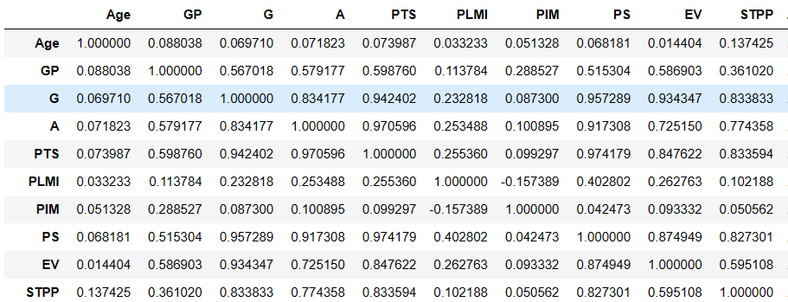

Figure 6 represents a partial snippet of a correlation map between all the different variables. The closer the score is to 1, the more the two variables show correlation between them. Unfortunately, I couldn’t show the entire correlation map due to size constraints, but for purposes of this paper, showing a snippet will be sufficient. I ran the algorithm once without removing any of the variables. Once I produced this correlation map, I was able to see which variables did not show a correlation with the cap hit. I removed the variables that showed a negative correlation score and ones that were less than 0.2. By doing this, I was able to use only the variables that showed some amount of correlation, which would hopefully improve the results of the prediction. Correlation can be calculated by the following formula:

Correlation = n(∑(x*y) - (∑x * ∑y)

√(n∑x^2 -(∑x)^2)(n∑y^2-(∑y^2))

In our equation, ‘n’ represents the amount of observations we have in our dataset, ‘x’ represents the number of independent variables, and y represents our dependent variable. These scores are always between -1 and 1, -1 being a perfect negative slope and 1 being a perfect slope. In our case, we want the stats that are going to show a correlation as close to 1 as possible and we want to delete the stats that show a correlation closest to 0 and below. The closer we get to 0, the more apparent it becomes that the two variables are not correlated.

Figure 9

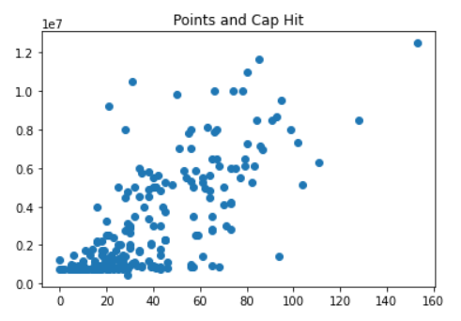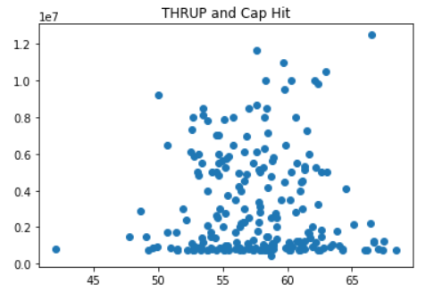

The above two scatter plots show 2 different variables, points (PTS) and thru percentage (THRUP) and how they correlate to cap hit for centers. As mentioned above, the algorithm was run with all the variables included and once again with the variables that showed a correlation score of less than 0.2. The MLR model showed that mostly offensive stats for centers showed the most correlation with a player’s cap hit. Face-off stats showed some correlation, but it was not as high as I would have expected. Later on, we analyze the results of this algorithm.

1. Lasso Regression

Lasso Regression works similarly to linear regression, but aims to improve it by performing feature selection while it is fitting the model. According to Glen, “Lasso regression is a type of linear regression that uses shrinkage. Shrinkage is where data values are shrunk towards a central point, like the mean” (Glen). In our MLR model, the coefficient values aren’t normalized, whereas in Lasso regression, they are. This means that the coefficient values are moved towards a value for 0. In order to calculate the penalty, we use the following formula:

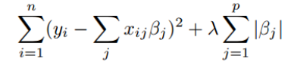

The equation above represents how the coefficients are normalized towards 0. By normalizing the coefficients towards 0, feature selection is being performed, thus eliminating the features that aren’t important. In the above equation, ‘y’ represents the dependent variable, ‘x’ represents the independent variable observations, ‘𝜷’ represents our coefficients, and ‘ℷ’ represents our alpha. The second part of the equation will represent the penalty that is incurred to each coefficient and this is what brings the coefficients down to 0.  While our MLR model will use all of the features, the pool of features is reduced significantly using Lasso. Our dataset features over 30 various stats, and when we use the Lasso model, about half, to more than half of the features get eliminated from consideration.

For the Lasso model, I started by assigning an alpha score of 0.1. Once I got the first prediction, I seeked to get a more optimal alpha score to see if that would improve upon the prediction. The process is very similar to the MLR model, the only difference is, the process of scaling down the coefficients and getting an alpha score that is most optimal for our data set.

CHAPTER 5

ALGORITHM RESULTS AND COMPARISON

Each algorithm was scored by their r-squared value, mean absolute error, and the accuracy score. The r-squared value shows us how well our models explain the data from our dataset. A perfect r-squared of 1 would mean that all of the observed data can be explained by our model, which means it would perform very well. R-squared can be calculated by:

r^2 = 1 -  (∑(yi - yp)^2)

  (∑(yi - ya)^2

The value ‘yi’ is the value that we are trying to predict, ‘yp’ is the predicted value, and ‘ya’ is the average of the sample. For the purposes of salary prediction, I would consider a r-squared value of above 0.6 to be a decent score. The mean absolute error is used to describe the average of the difference between the actual value and the predicted value. The formula is as follows:

Mae = ∑(yi - yp)

    N

The value of ‘yi’ represents our actual value, ‘yp’ represents the predicted value, and ‘n’ represents the predicted values from our test set. For the purposes of salary prediction, if the model is around 1 million, I would consider that fairly successful. The last metric used to score the model is the accuracy score. The accuracy score simply takes the number of accurate predictions and divides it by the total number of predictions. The accuracy score is the least metric I am worried about for this project, but having an accuracy score that’s above 35% is what I would value to be successful.

1. Random Forest Results

Figure 10

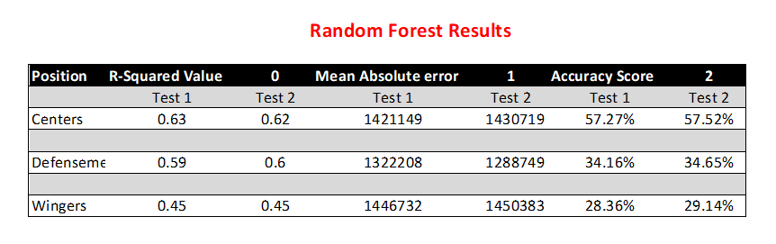

The random forest model showed strong predictions for the centers and defense as their r-squared values were above or around 0.6. This means that 60% of the predictions can be explained by the model. This model was accurate due to the fact that it samples random data points from the dataset and never uses the whole set. For each position, our mean squared error was around 1.2 million - 1.4 million, meaning that our predictions were off by those numbers. Considering that salaries can range from 750,000 to 12.5 million, this amount of error is not small, but it isn’t large enough to say that the predictions were off. Each tree operates independent of the others and each tree samples random data points from the dataset. Due to this, we can get more variety of data being used, thus helping us achieve higher accuracy in our predictions. Below are the outputs of the various predictions. Each one shows what the actual salary is, the first prediction, the difference of the actual salary and first prediction, the second prediction from removing certain features, and the difference between the actual salary and second prediction.

Figure 11 (Defense)

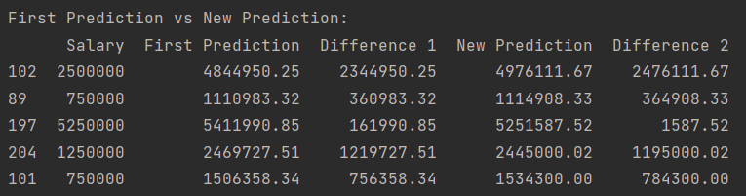

Figure 12 (Wingers)

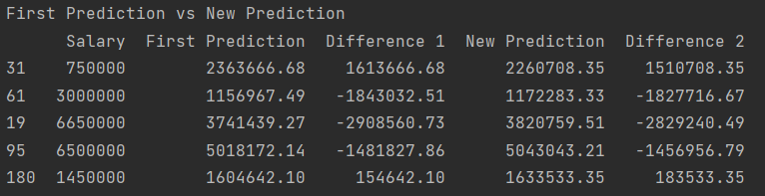

Figure 13 (Centers)

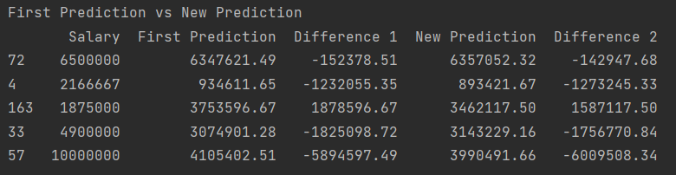

1. Multiple Linear Regression Results

Figure 14

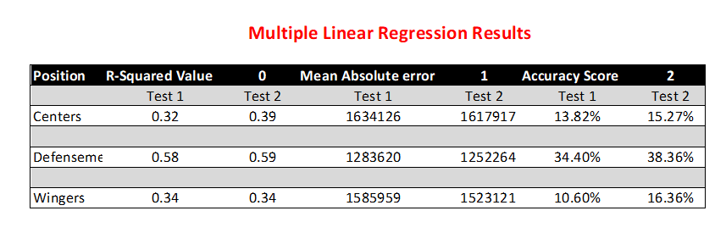

Overall, the MLR algorithm performed fairly low compared to the other algorithms. This could be explained by the fact that the entire dataset is used. Random forest provides the flexibility of using random data points and splitting them. MLR is stuck with the coefficient of each feature. Even with removing less important features, the r-squared value is fairly low for the positions, with the exception of defense. This could be explained by the higher variation in stats between centers and wingers. Defenseman stats, when it comes to offense, typically don’t vary far. It could be harder for the model to use stats such as goals, points, and assists for centers and wingers, due to the fact that there is a large disparity. The mean absolute error for this model was also fairly high, ranging from 1.2 million - 1.6 million. Below are the outputs of the various predictions. Each one shows what the actual salary is, the first prediction, the difference of the actual salary and first prediction, the second prediction from removing certain features, and the difference between the actual salary and second prediction.

Figure 15 (Defense)

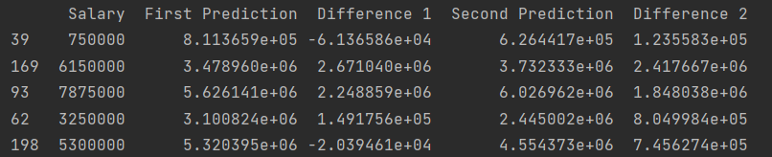

Figure 16 (Wingers)

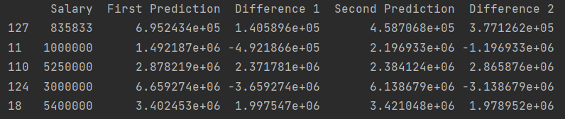

Figure 17 (Centers)

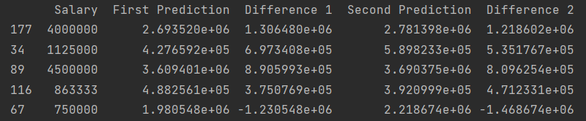

1. Lasso Regression Results

Figure 18

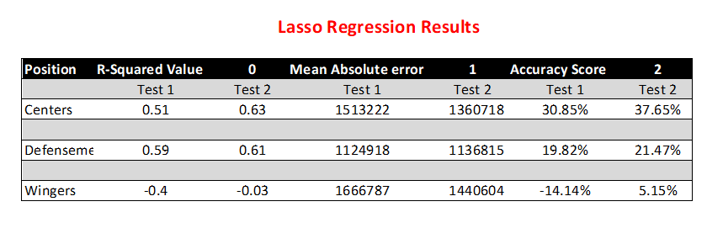

The Lasso model produced fairly accurate results, with the exception of the wingers stats. This was very surprising to see, but the model found no correlation between player productivity and their salaries. However, the model showed tremendous improvement when applied to centers and stayed fairly consistent with defensemen. Even though defensemen improved very little and the wingers were still negative, the model showed improvement. This can be attributed to its feature selection and the elimination of stats that weren’t as important. The model identified these stats by reducing their coefficients down to 0, making it so we didn’t have to consider those stats the second time we ran the algorithm. As stated before, there were over 30 different player stats in each of the datasets, and the lasso algorithm cut the number of features to around half. This offered a better outcome because we only saw the stats that mattered to our prediction. The mean absolute error was also the lowest as it ranged from 1.1 million - 1.5 million. Below are the outputs of the various predictions. Each one shows what the actual salary is, the first prediction, the difference of the actual salary and first prediction, the second prediction from removing certain features, and the difference between the actual salary and second prediction.

Figure 19 (Defense)

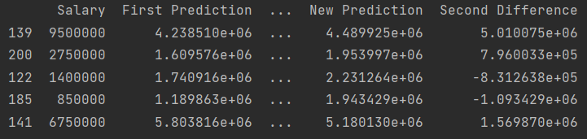

Figure 20 (Wingers)

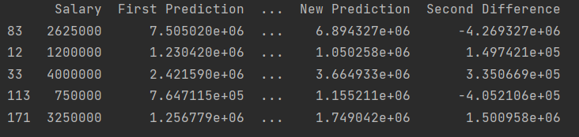

Figure 21 (Centers)

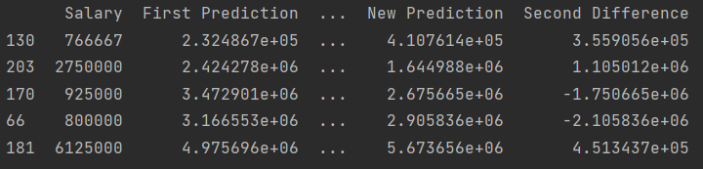

Chapter 6

CONCLUSION

This project aimed to investigate whether or not a player’s stats could be used to predict their salary. From the results, I believe we can give a fairly accurate prediction of what a player should make, based upon their production. Out of all the algorithms, Random Forest produced the most consistent results across the board. Even though the r-squared was lower for wingers, it still out performed MLR and the lasso algorithms. I believe this can be attributed to the flexibility of the Random Forest algorithm. As stated before, Random Forest picks random stats from the dataset and produces a series of decision trees that are independent of each other. The summary of these results was then used to output the final prediction. This allowed for more variety of the dataset to be used and considered. The Lasso algorithm showed improvement for all datasets once the coefficients that were least important were removed. This acted as feature selection, but it still was not as flexible as Random Forest. The MLR algorithm was by far the worst of the 3 algorithms used. This was due to the fact that the whole dataset was used each time, meaning there was no room for variety. I did initiate some feature selection by choosing stats that showed a correlation of higher than 0.2, but it didn’t contribute to much improvement the second time the algorithm was run.

A limitation of this study was my decision to leave players with entry level contracts. Other studies argued that having them in would reduce the accuracy of the model because their salary isn’t dependent on their performance. The problem with this is that some players are near the end of their entry level contracts and could be entering free agency where they can sign a higher value deal, meaning that their performance does affect their salary.

This project’s goal was to see how stats were used to determine what a player should be paid. While the models showed effectiveness, I would argue that stats alone cannot be the only factor that goes into determining a player’s salary. Other factors are fan attendance, a player’s jersey sales, their leadership, feeling amongst teammates and coaches, and what the player means to the city and organization that he plays for. Jersey sales and ticket sales are quantifiable stats and could improve upon determining a player’s salary, but what the player means to the city, leadership traits and respect from players and coaches can be a determining factor as well, and these stats cannot be quantified. What fans see is the production, or lack thereof, on the ice, but the intangible factors play a bigger role than we might think. There is no doubt that there is a correlation between a player’s production and their salary, but their salary can’t be solely based on how they play.

WORKS CITED

Fortney, Thomas, et al. "National Hockey League Fights per Game and Viewership Trends: 2000-2020." *Frontiers*, 30 Jun. 2022, www.frontiersin.org/articles/10.3389/fspor.2022.890429/full#:~:text=Conclusions%3A%20NHL%20fighting%20rates%20have,doubt%20on%20fighting's%20entertainment%20value. Accessed 20 Apr. 2023.

Glen, Stephanie. "Lasso Regression: Simple Definition" From [StatisticsHowTo.com](https://www.statisticshowto.com/): Elementary Statistics for the rest of us! <https://www.statisticshowto.com/lasso-regression/>

Lee, Ceshine. “Feature Importance Measures for Tree Models — Part I.” Medium, 8 Sept. 2020, medium.com/the-artificial-impostor/feature-importance-measures-for-tree-models-part-i-47f187c1a2c3.

Li, Chenyao, et al. *Machine Learning Modeling to Evaluate the Value of Football Players*. 2022. University College London, Final Project.

Morthi, Aparna. "How Lasso Regression Works in Machine Learning." *Dataaspirant*, 26 Nov. 2020, dataaspirant.com/lasso-regression/#t-1606404715787. Accessed 19 Apr. 2023.

Ozanian, Mike, and Justin Teitelbaum. "NHL Team Values 2022." *Forbes*, 22 Dec. 2022, www.forbes.com/sites/mikeozanian/2022/12/14/nhl-team-values-2022-new-york-rangers-on-top-at-22-billion/?sh=eb74d967deb1. Accessed 18 Apr. 2023.

Stephanie. “Lasso Regression: Simple Definition - Statistics How To.” Statistics How To, 27 Apr. 2021, www.statisticshowto.com/lasso-regression.

Tonack, Austin. *Determining an NHL Center’S Value: Salary Prediction Based on Performance Data*. 2018. Project.

hockey-reference.com

"NHL Salaries Over the Years." *HockeySkillsTraining*, www.hockeyskillstraining.com/nhl-salaries-over-the-years/. Accessed 19 Apr. 2023.

APPENDIX A

GLOSSARY OF TERMS

|  |  |
| --- | --- |
| A | assists - first or second person to pass to the eventual goal scorer |
| Age | age - how old the person is |
| BLK | blocks - how many shots a person blocked |
| CA | corsi |
| CAPHIT | cap hit - a player's aav of their contract |
| CF | corsi at even strength (shots+blocks+misses) |
| CFP | corsi for percentage |
| CFPR | relative corsi for percentage |
| DZS | defensive zone start percentage |
| EPLMI | expected plus minus |
| EV | even strength goals - how many goals a player has when it is 5 on 5 |
| EVA | even strength assists - how many assists a player has when it is 5 on 5 |
| FA | fenwick against (shots + misses) |
| FF | fenwick for (shots+misses) |
| FFP | fenwick for percentage |
| FFPR | relative fenwick for percentage |
| G | goals - total number of goals a player has scored |
| GP | games played - total number of games a player has played |
| GV | giveaways |
| GW | game winning goals - how many goals a player has that resulted in winning the game |
| HIT | hit - how many hits or checks a player has |
| OISH | team on ice shooting percentage when player is on the ice |
| OISV | team on ice save percentage when player is on the ice |
| OZS | offensive zone start percentage |
| PDO | shooting percentage plus save percentage |
| PIM | penalty in minutes - total number of minutes a player spends in the penalty box |
| Player | player - name of the player |
| PLMI | plus minus |
| Pos | position - what position a player plays |
| PPA | power play assists - how many assists a player has on the power play |
| PS | point share |
| PTS | points - goals plus assists |
| S | shots - how many shots a player has |
| SHA | short handed assists - how many assists a player has when they are short handed |
| SP | shot percentage - total goals divided by total shots taken |
| STPP | special teams power play - how many goals a player has while their team is on the power play |
| STSH | special teams shots - how many shots a player has on the power play |
| THRUP | thru percentage - number of shots that record as a shot on goal |
| TK | takeaways |
| Tm | team - what team a player plays for |
| TSA | total shots attempted |
| TTOI | total time on ice - total minutes a player has spent on the ice for the season |